

Document Control
Q-0002
Revision A

Revision History
Rev | Status | Date | Author | CO# | Description
A | Draft | 9/23/04 | CB |  | Initial document release
A | Draft | 4/7/10 | S.Belanich |  | Preparation for release.

Training
Role | New | Trained in previous rev.
Document Coordinator | Instructor-led | Not applicable for Rev A
Author | Instructor-led | Not applicable for Rev A
Reviewer/Approver | Instructor-led | Not applicable for Rev A
Implementer | Instructor-led | Not applicable for Rev A
Document Readers | Core QS Training | Not applicable for Rev A

Purpose
MedCommons controls policy, process, and procedure documents to ensure that:
- Documents are reviewed and approved before use.
- Current documents are available to personnel performing related tasks.
- Obsolete documents are retained for at least five years for business review and audits but so as not to be confused with current documents.

Because the MedCommons quality system is based on documents, the process of document control is the fundamental change control mechanism for MedCommons’ policies, processes, and procedures.

Scope
This Document Control process applies to documents that describe policy, processes, and procedures.

Definitions

Document
A document contains information, such as policies and descriptions of processes and procedures, which is intended to be followed in the future. This it may be revised in the future.

Record
A record contains information that describes an event. In the future it is used for historical purposes, including analysis and audit. It may be corrected if in error, but is not revised otherwise.

Quality System Record (QSR)
The QSR includes documents and records related to activities in the quality system that are not specific to a particular product.

Design History File (DHF)
The DHF includes documents and records related to the development of a particular product.
Device Master Record (DMR)
The DMR includes documents and records (such as process validation records) related to the replication, testing, and distribution of a product type or model.
Device History Record (DHR)
The DHR includes records related to the replication, testing, and distribution of particular units, e.g., lots or serialized copies of software.
 | Documents | Records
Not product-specific | Quality System Record (QSR)
Product-specific Design | Design History File (DHF)
Product-specific Manufacture and Distribution | Device Master Record (DMR) | DMR if not unit-specific
Product-specific Manufacture and Distribution | Device Master Record (DMR) | Device History Record (DHR) if unit-specific

Responsibilities

Document Coordinator
The Document Coordinator oversees document processing and maintains the Released and Obsolete document folders.

Author
Authors gather information about their document’s topic, meeting with affected personnel to understand user needs. They create the document, work with the Document Coordinator, and resolve reviewers’ comments. It is the author’s responsibility to obtain reviewers’ approvals.

Reviewer/Approver
Reviewers read draft documents and comment on correctness and appropriateness. After issues are satisfactorily resolved by the author, the reviewer approves the documents.

Implementer
The implementer is responsible for ensuring that implementation tasks are completed in a timely manner.

Document Reader
The document reader is responsible for ensuring that he has the current revision of the document. The document reader follows the policy, process, or procedure as described in the document. If the document is in error or should be revised, the document reader notifies the Document Coordinator or the Author, if known and available. The document reader does not deviate from policy, process, or procedure without notifying and getting permission of his supervisor or manager.

Records created
Record type | Form or template | Where filed
Revisions of documents | Q-0002 Form A | Released QS Documents folder
Change Order | Q-0002 Form B | Change Orders

Referenced Documents
- Q-0001 Quality Manual
- Q-0005 Document Naming Convention

Procedure
See flow chart on next page. The following provides details for the steps in the flow chart.

Gather info | Policies, processes, and procedures typically affect many personnel. Consult with representatives of those affected and have informal draft reviews as appropriate.
Draft new or revised document | For new documents, use the Document Template, Q-0002 Form A.  For revisions, you may start with the last draft in the Draft QS Documents folder.
Draft associated Change Order | A Change Order is the record of the review and approval of the document and the implementation tasks needed for the change. Use the Change Order Template, Q-0002 Form B.  For each document, indicate the Subversion revision level to be reviewed. (It is essential that reviewers approve the same draft revision.)  The Reason for the Change is intended to tell reviewers why the change is appropriate.  Implementation Tasks typically include training of personnel and validation of processes or software tools affected by the change. It may include purchasing of inventory and using existing inventory.  If other documents are made obsolete by this change, their obsolescence should be an implementation task assigned to the Doc Control Coordinator.
Enter to Draft QS Documents | Place the draft document and draft Change Order in the Draft QS Documents folder and notify the Doc Control Coordinator.

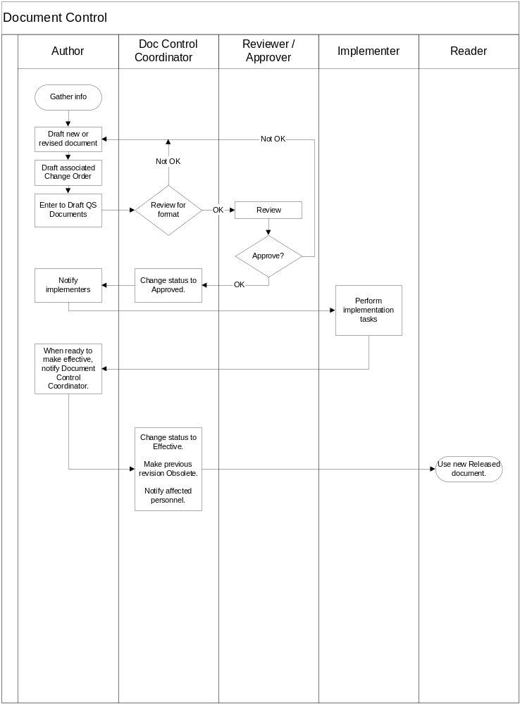+

Review for format | The Doc Control Coordinator reviews the drafts to ensure proper naming conventions, complete information, and adherence to good document practice. If there are problems, the Doc Control Coordinator notifies the Author and explains the nature of needed changes. If not, the Doc Control notifies the Reviewers.
Review | There are at least two reviewers. The Author is not a reviewer unless the author is the CEO reviewing as Management Reviewer.  The Management Reviewer approves if the document is proper for the business and if resources will be committed to implement and perform the documented policy, process, or procedure.  The Quality/Regulatory Reviewer approves if the document is consistent with MedCommons quality goals and methods and conforms to regulatory and standard requirements.  A Subject Expert Reviewer(s) is added at the request of the Management and Quality/Regulatory Reviewers. A Subject Reviewer(s) approves if the document is correct and appropriate considering the technology or subject of expertise.
Approve? | If the reviewers find issues or problems, they are communicated to the Author who resolves them.  If a change is made after a reviewer has approved it, the reviewer must review and approve the changed draft unless the change is purely editorial. If there is a question whether the change is editorial, the Quality/Regulatory Reviewer shall decide.  If all reviewers approve, the Change Order is signed and the Doc Control Coordinator is notified.
Change Status to Approved. | The Doc Control Coordinator changes the Status indicator in the Revision History and document header from “Draft” to “Approved” and notifies the Author.
Notify implementers | The Author notifies the implementers listed in the Implementation Tasks table and follows up with them to ensure timely implementation.
Perform implementation tasks | The implementers work with the Author and others to perform the Implementation Tasks. When they have completed their tasks they notify the Author and the Doc Control Coordinator. (If a problem arises, a change to the implementation plan may be needed. If significant, the Change Order should be revised, reviewed, and approved.)  Examples of implementation tasks:  - Minimum training sufficient to begin using a procedure, For example, train the coordinator(s) and the first people to perform the task. (Personnel should not perform the task unless their training record is signed.)  - Validation of software tools or processes used to create the product or to automate quality system functions.
When ready to release, notify Document Control Coordinator. | When all implementation tasks are complete, the document may be released as soon as the Author has ensured all is in readiness. When a document is released, it must be used. The timing of release must match the timing of actual use of the document. Typically, this is a simple confirmation. It may be made in advance. However, if there is any concern about the timing of the change, the Author should coordinate with the Document Control Coordinator.
Change status to Released.  Make previous revision Obsolete.  Notify affected personnel. | The Document Control Coordinator changes the status in the Revision History and document headers from “Approved” to “Released”. A pdf copy of a document is placed in the Released Documents folder. An application (e.g., Word or Excel) copy of a Form is placed in the Released Documents folder.  The Document Control Coordinator confirms that obsolete revisions are no longer available to users in the Released Documents folder. (Personnel are trained that only the most recent revision in Released Documents is to be used. Previous revisions are obsolete.  The Document Control Coordinator notifies affected personnel of the release of the new document and the obsolescence of the previous revision and other documents, if any.

Maintaining the QSR, DHF, DMR, DHR index

Documents are stored in the Released Documents folder in Subversion. Records are stored in locations defined in the documented procedures that created the records.

The four indexes point to the locations and identifiers of the documents and records. The Document Control Coordinator maintains a Documentation database. When a document (original or revision) is released, the Coordinator confirms the document is entered into the database. The appropriate index category is checked. If records are created by the documented procedure, the Coordinator enters the record type(s) into the Documentation database. The appropriate index category is checked.

A QSR, DHF, DMR, or DHR index can be created on demand. An index lists the documents and record types in the category, where they are located, and any identifiers.

